**TIMECARD ONLINE will now be a new tab available  
through the EMPLOYEE ONLINE product.**

SAVE to revisit at a later date, and to calculate totals



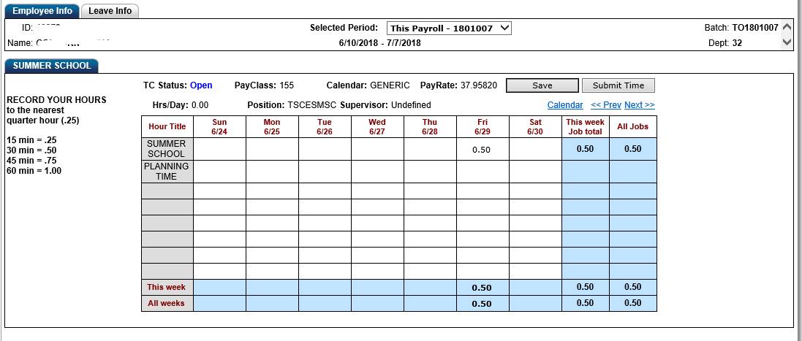STEP 1: Choose from an open pay period

STEP 3: SUBMIT to send for approval

STEP 2: ENTER hours (rounded to nearest .25 hours) on the appropriate dates, under the applicable program and hour. Use the “Next” or “Prev” link to move between open weeks.

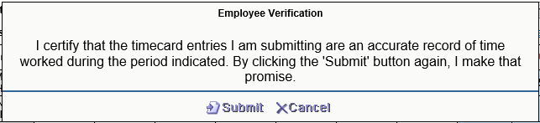

STEP 4: Before clicking on SUBMIT, be sure you have entered ALL your additional time for the pay period identified. Once submitted, the records will route for approval and you will not be able to add or edit the records. If an error has been identified, you will need to contact the payroll department.

You will receive an email, as shown below, once your records have completed the electronic approval process.

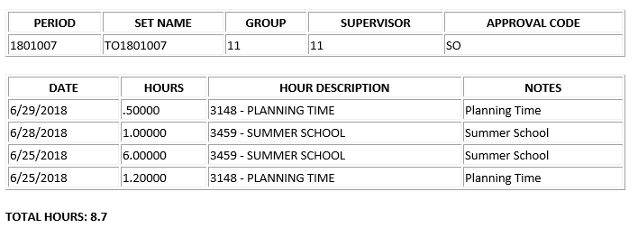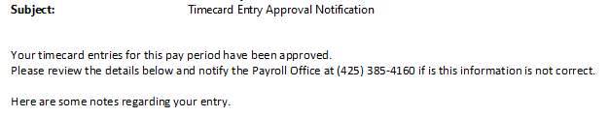

**SUMMER SCHOOL  
PAY PERIODS**

JULY (1801007): June 10– July 7  
paydate: July 31

AUGUST (1801008): July 8 – Aug 11  
paydate: August 31

SEPTEMBER ACCRUAL (1801108): August 12 – August 31  
paydate: September 21